**Group Project Plan & Function Selection**

1. **Project Overview**

This project is designed to manage hotel room bookings and related operations. The system is focused solely on managing room data without handling user details. All room information will be stored in a .txt file instead of a database, providing a simple and accessible storage method. The project will implement the following functions,

01. Show all rooms()

02. Show booked rooms()

03. Show available rooms()

04. Add a room()

05. Remove a room()

06. Book a room()

07. Release a room()

08. Show A/C rooms()

09. Show non-A/C rooms()

10. View room prices()

1. **Function-wise Explanation**
   1. **Main function()**
      1. **Display Menu:**

* Show the list of available actions (functions) to the user:
  1. Show all rooms
  2. Show booked rooms
  3. Show available rooms
  4. Add a room
  5. Remove a room
  6. Book a room
  7. Release a room
  8. Show A/C rooms
  9. Show non-A/C rooms
  10. View room prices
  11. Exit (Not a function)
      1. **User Input:**
* Prompt the user to select an action by entering the number corresponding to the desired function.
  + 1. **Input Validation:**
* Check if the user’s input is valid (i.e., a number between 1 and 11).
* If the input is invalid, display an error message and prompt the user to enter a valid option.
  + 1. **Execute the Selected Action:**
* Based on the user's input, call the corresponding function to execute the action.
  + 1. **Loop Continuously:**
* The program should continue running in a loop, allowing users to select actions repeatedly until they explicitly select **11** to exit the program.
  + 1. **Exit:**
* If the user selects **11**, the program will break the loop and exit.  
    
    
    
    
    
    
    
    
    
    
    
    
  A diagram of a diagram

  AI-generated content may be incorrect.
  1. **Show all rooms function()**

True

* + 1. **User inputs:**
* No user inputs
  + 1. **Expected output:**
       - * List of all rooms in the hotel
  1. **Show booked rooms function()**

***Please read and understand how data is stored before this part.***

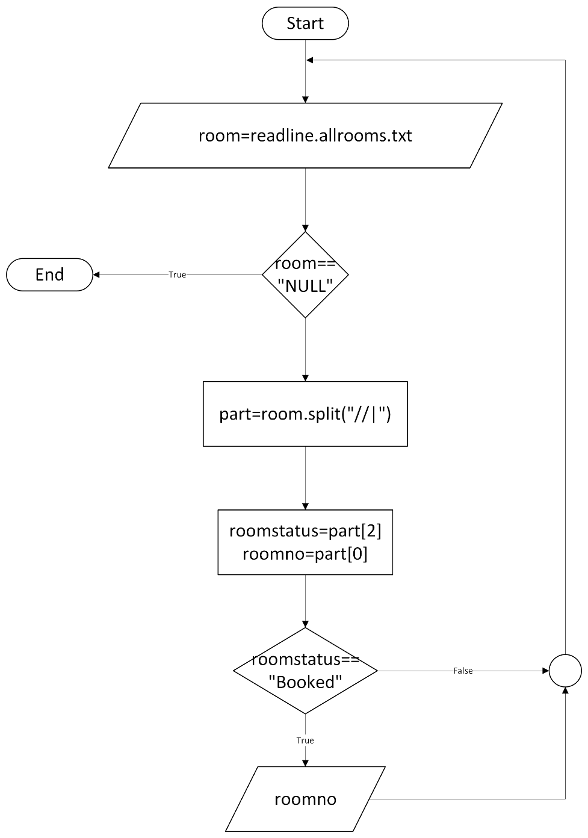

* + 1. **User inputs:**
* No user inputs
  + 1. **Expected output:**
       - * List of all booked rooms in the hotel
  1. **Show available rooms function()**

***Please read and understand how data is stored before this part.***

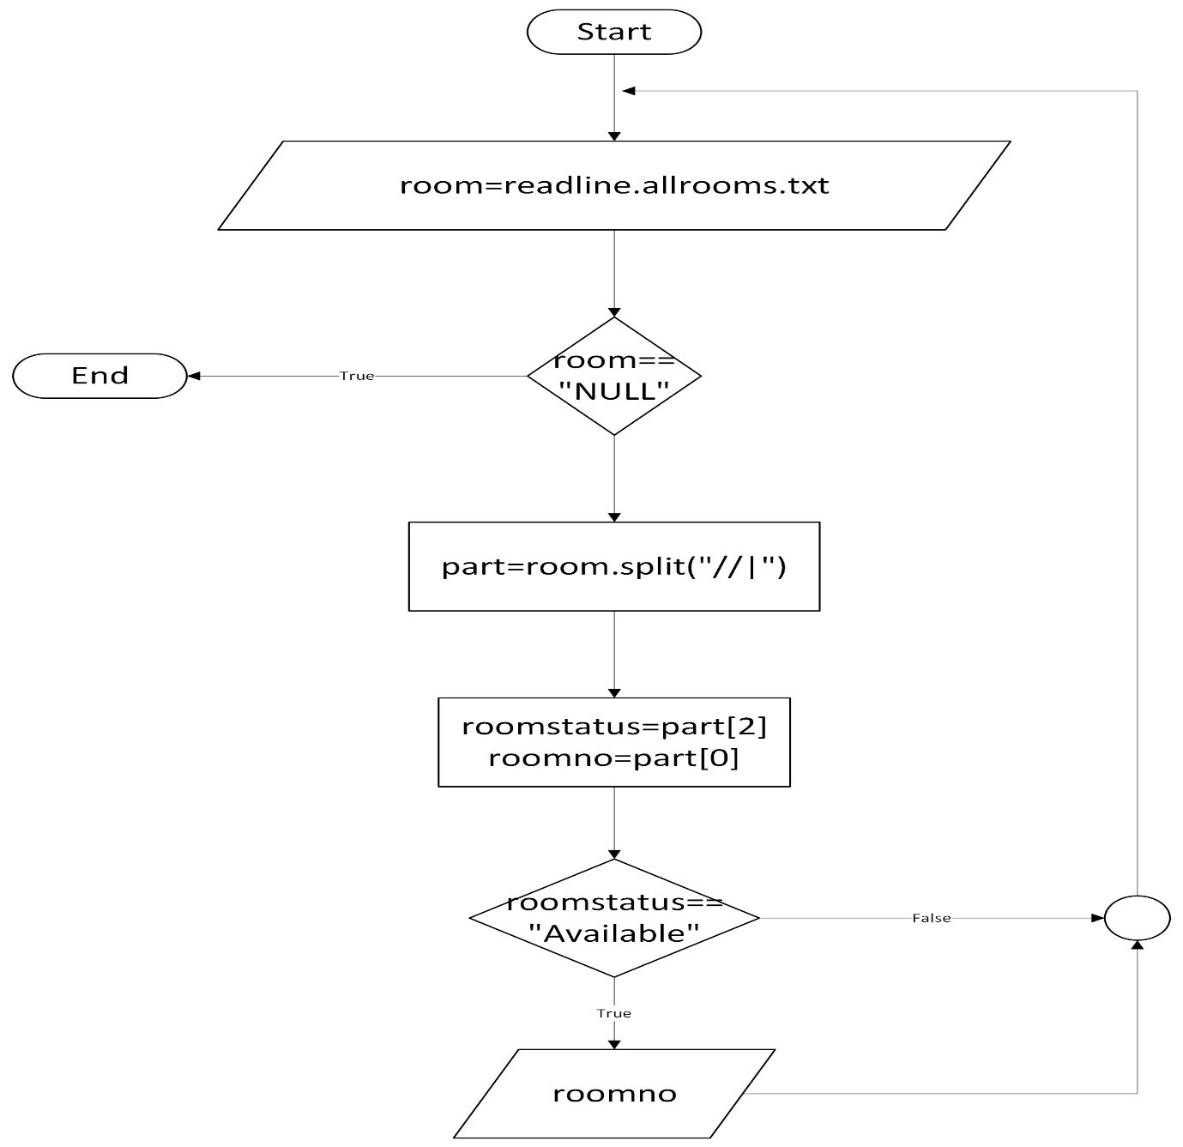

* + 1. **User inputs:**
* No user inputs
  + 1. **Expected output:**
       - * List of all available rooms in the hotel